COLORES FLEET

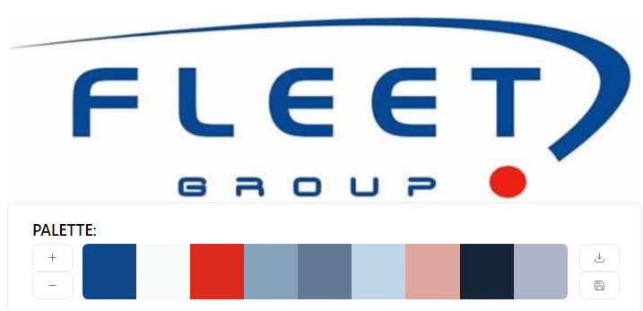

#0e4888 #f6faf8 #df281e #88a3be #637893 #bfd4e7 #dca79f #142538 #acb4c6